31 December 2009

Meeting With STD Researchers from CDC

On 29 December 2009, Tony and I met with three members of the Global STD Group at the United States Centers for Disease Control and Prevention in Atlanta, Georgia: Ron Ballard, who heads the department; Lisa Steele, who is in charge of international epidemiology and public health studies; and Dave Trees, who runs the department’s gonorrhea lab. There would have been much broader attendance at the meeting, but for the fact it was set between the Christmas and New Years holidays – a function of the scheduling of our meeting at Thermo Fisher the following day.

The meeting was set-up for us by Lisa Steele, with whom I have a close personal relationship. Tony enjoys a friendly relationship with Dave Trees (and his wife Aja, who is also a researcher at CDC) going back more than a decade.

Ron Ballard was delighted to meet with us, though he said at the outset he thought we might be “preaching to the converted”; he and his team are quite impressed with the utility and efficacy of Genelock. We explained that we had three objectives for the meeting: (a) to introduce them to new product formulations and interesting applications with relevance to STD research, (b) to get specific feedback on the ways our HIV Whole Blood Tube might be used within existing programs of testing and treatment within specific developing world contexts, and (c) to explore the possibility of working with CDC to make the HIV Blood Tube broadly available for global health applications. Each of those objects was met in the course of the meeting.

Discussions re Genelock Products in STD Research

We presented the new multiplex formulation and used the work of David Martin’s group at LSU to illustrate the product’s utility. We also ran-through the other examples of interesting applications on the Technology Nontechnical Overview Slides.ppt presentation, which included the Planned parenthood situation, the prostate cancer research, and the study of obligate bacteria.

Ron asked if we were still aiming to sell the company and, if so, if we had approached Gen-Probe. He, Lisa, and Dave were strongly of the opinion that Gen-Probe would soon be the leader in development of molecular assays for STDs and that their current development was focused on swab-based collection devices – not unlike ours.

Lisa explained Ron’s enthusiasm for Gen-Probe over dinner that evening. She disagreed a bit with Tony’s statement at the meeting (which I didn’t recall) that urine would continue to be the dominant format for STD sampling. She believes that vaginal swabs are the collection method of choice. She had seemingly solid reasons for this. Women bear the brunt of STDs, both because they provide more hospitable environment for STD bacteria and because they manifest disease upon certain infections in ways that men do not. Urine sampling in women give extremely low yields of bacterial targets for the same reason urine samples produce fairly decent yields in infected men: the path of the urinary tract. Vaginal swabbing is therefore a greatly preferred method of sample collection for STDs in women. Lisa agreed that urine will continue to be the preferred method of collection for men, not least reason being the reluctance of men to undergo urethral swabbing.

She thought the Planned Parenthood example – in which high-volume labs were using Genelock to improve sensitivity in the assays and avoid the need for repeats – was interesting. She said the easiest way to improve the certainty of the diagnostics was to use samples from high-prevalence areas (i.e., vaginal swabs); but the Planned Parenthood example illustrates the way in which labs are prisoner to the formats of the instrumentation pushed on them by manufacturers like Becton Dickenson. Basically, the reason Planned Parenthood is running urine samples for Ct/Ng diagnostics is that the BD Viper instruments are set-up to run it.

The Practical Logistics of HIV Testing in Africa
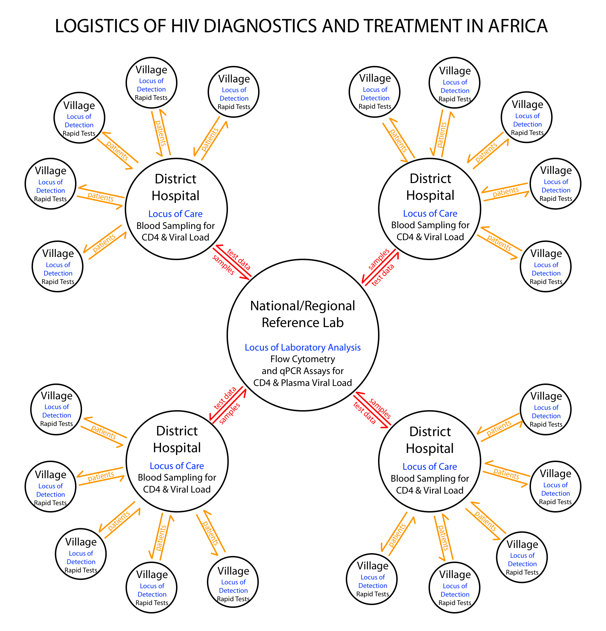
We read a lot of policy declarations from WHO, Gates Foundation, and the like about the systems that will be established to effectuate the goal of universal HIV testing in Africa. None of it meshes with the anecdotal descriptions we get from those involved with the epidemiology work at University of Washington and University of California at San Francisco. So we put it to Ron: how does HIV testing presently work in Africa and how might you envision our HIV tube fitting in to the mix?

Ron began by differentiating testing for primary detection and testing as a tool of proper treatment. Our Hemolock Universal Whole Blood HIV Tube falls into the latter category. He sketched out a crude version of the diagram to the right, which I have reproduced and embellished.

Patients are screened for HIV in the villages. Positive cases are sent for further testing and treatment at district hospitals. These hospitals rely on laboratory support from national or regional reference labs, which operate flow cytometry and qPCR labs.

Primary detection is presently done with “point of care” rapid assays. These are expensive, but allow for prompt determination and minimize the practical difficulties of maintaining communication with patients when testing occurs at a remote location and results are not available at the time when field workers are face-to-face with the patients. There is not really a role for our collection device in primary detection.

Testing is, of course, a critical aspect of treatment, both for initiating antiretroviral therapy and for monitoring its efficacy and the development of resistance. Currently, this is done with immunophenotyping, using T cell counts as the relevant biomarker. Flow cytometry or alternate immunoassays are used to count CD4 (T-helper cells) or measure CD4:CD8 ratios (T-helper cells and T-suppressor cells). Often, plasma viral load is also measured. From Ron’s point of view, the ability to obtain accurate viral load should obviate the need to do immunophenotyping, since the proliferation of the virus is a perfect indication of the degree to which the immune system has been compromised. (I think this is an oversimplification because, if for no other reason, diagnostic ranges have been well established for altering ART with CD4.) The standard approach is to do both tests, both at the time of initial diagnosis and throughout the course of antiretroviral therapy. This is obviously the place where our HIV Whole Blood Tubes have value.

We did not discuss the other point of obvious utility: HIV genotyping for individual diagnostics and public health studies of patterns of resistance.

Companion diagnostics to antiretroviral therapy creates the greatest logistical difficulty in the typical African treatment scenario. Treatment tends to be based from district hospitals, which are also the locus of sampling for CD4 and viral load testing. These hospitals typically lack the ability to run the assays locally. Instead, the samples are transported to national or regional reference labs, usually located in capital cities or other major metropolitan areas. The expense and difficulty of transporting samples has created an enormous market opportunity for the BD/Streck tubes since 2006 and could naturally do the same for us.

Lisa put this point into sharp focus during our dinner discussion, in the context of her global STD studies. “People may not understand the full significance of what your products do because they look at the problem abstractly,” she said. “But I’m the one who prepares and controls the budgets for these studies; and considering everything that’s involved, sample transportation can easily be 50% of the cost in some studies.”

Validating Hemolock Universal HIV Whole Blood Tubes

We put the question to Ron directly: could he see a way we could work with the CDC to validate the Universal HIV Whole Blood Tubes? His response was immediate and enthusiastic.

Ron volunteered to advocate the idea of a validation study with John Nkengasong, the director of CDC’s Global AIDS Program, who will be back in Atlanta the second week of January. He suggested that John could easily find funding for such a study.

Dave and Lisa laughed when Ron suggested South Africa as the natural venue for the study – because Ron is, in fact, South African – but all agreed it made perfect sense. South Africa has both the ubiquity of patients and the availability of centralize laboratory facilities necessary. One of the CDC’s partner research institutions in South Africa could clear the study through an IRB.

Ron recommended a simple study in which twin blood samples would be collected at a district hospital and transported for analysis at a regional reference lab. One whole blood sample would be collected in our tubes and transported unrefrigerated to the lab; the other would be processed according to current best-practices. Viral load would be measured by qPCR at the lab and the results compared.

We suggested that if current best-practices in Africa involved fractioning of the sample and transporting frozen plasma, the protocol he recommends sounds simple and inexpensive. If there is a less advantageous method currently employed, we should include a control at the point of collection, which would involve installation of qPCR at the district hospital in order to get an untransported, T₀ viral load reading.

My subsequent thoughts on this include two other ideas, which I will memorialize here so as not to lose them. First, I think we should monitor the relative costs of collection and transport if the comparison is to fractioned and frozen or refrigerated plasma. It will be useful to compare both performance and expense, since both factors weigh-into public health decision-making. Second, I think we would benefit from a head-to-head study of CD4 against the BD/Streck Cyto-Chex tubes. I would like to run such a study privately first, however, so we could have confidence in the outcome before allowing it to go forward as part of a CDC study. Nikhil Phadke could make this happen for us in India relatively inexpensively.

Columbia Study

Tony shipped swabs to Lisa last year for a study she was putting together in Columbia; but we had no information whatsoever about that research. I received a debriefing over dinner.

The work grew out of an approach to CDC from a university in Columbia (I don’t know which one), which had received government funding to study the reproductive health of the country’s internally displaced women. (The UNHCR estimates the population of IDPs in Columbia at 3 million as of January 2009.) The principal investigators wanted assistance in study design and protocol development. CDC decided to use this study as an opportunity to partner with the academic researchers to conduct a parallel survey of STDs, collecting vaginal swabs for detection of Mycoplasma genitalium, Chlamydia trachomatis, Neisseria gonorrhoeae and Trichomonas vaginalis.

According to Lisa, this study has been a fiasco in every major respect except one: Sierra Molecular’s contribution. The patient sampling has been long-completed, but none of the specimens have been assayed. Apparently, there is some conflict within the university involving funding and the Government of Columbia refuses to intervene. She anticipates this to be resolved soon because the IRB study approval will expire sometime in mid-year.

Once this study is completed, it will be a nice feather in our cap.

One reason Ron is such a fan of Sierra Molecular, and was so willing to meet with us on what was supposed to be a day-off for him, is our contribution to this study.

Takeaways

We should speak with Gen-Probe as a potential acquirer. According to the STD team at CDC, its Aptima assay could challenge BD for dominance in Ct/Ng diagnostics the near future. Tony had an extremely negative experience when approaching Gen-Probe; but that was years ago under different circumstances and, in any case, we have nothing to lose.

Lisa will keep us advised about the approach to John Nkengasong. We should know what we want to do, in a fair detail, before we speak with him.

We stopped visiting researchers who use our products when our cash evaporated. That was understandable; but we learn extremely important things by visiting those who make use of our products. This includes cool things we can brag about and significant details about the research or clinical landscape that alters the way we speak about our products to show them to best advantage.

MBJ:

